**Principles of Communications**

Channel Estimation & Equalization

**Aim of the Project**

* 1. Understand the need for channel equalization and validate its functionality.
  2. Understand basic algorithms for channel estimation and channel equalization.

**Requirement of the Project**

* 1. This project requires **two students** to work as a team. In case a team cannot be formed, **one student** working alone is also acceptable.
  2. You must do the experiment with USRP and be tested by TA.

**Contents of the Project**

**Summary**

This lab will introduce digital transmission and reception in a frequency selective channel, where multiple paths in the propagation environment create distortions in the transmitted signal. Correcting for distortions introduced by the channel requires more complicated receiver processing. In this lab you will implement additional features in the transmitter and receiver to mitigate channel distortions. The main concepts explored in this lab are linear least squares estimation and linear equalization. You will valificate the functionality of the module in a simulator. Then, you will implement the system in lab using the USRP hardware to see how it works over a real wireless link. The goal of this lab is to understand the need for channel equalization and to understand basic algorithms for channel estimation and channel equalization.

* + - 1. Background

In wireless communication systems, the signal encounters effects in the propagation environment including reflections, scattering, diffraction, and path-loss. The different mechanisms of propagation create multiple propagation paths between the transmitter and receiver. For example, if there are two propagation paths, the receiver may observe the signal



which consists of two different delayed, attenuated, and phase shifted versions of the signal x(t). The delays τ 0 and τ1 are determined by the propagation time of the paths, which would generally be different. If the difference τ1−τ0 is significant (at least afraction of asymbol period T) then the received signal will experience intersymbol interference. This can not be corrected using the symbol synchronization techniques since there is a sum of two different received signals.

In general, there may be many propagation paths between the transmitter and the receiver. A good generalization of Eq. (1) is



where he(τ) is the baseband frequency selective channel. For complex pulse amplitude modulations, the channel distorts the pulse-shaping function. Consider the received signal after matched filtering and down-sampling. Using  for convolution define  and let  be the sampled version of the channel. Then

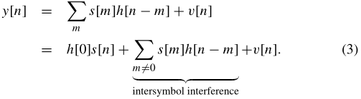

Unless h(t) is a Nyquist pulse-shape, the second term in Eq. (3) will not be zero.

There are two main challenges associated with the received signal in Eq. (3).

1. The channel coefficients  create intersymbol interference. The solution we pursue in this lab is to augment the detection procedure with a linear equalization step.

2. The channel coefficients  are unknown to the receiver. The solution we pursue in this lab is to estimate the unknown channel coefficients and use them to determine the linear equalizer, or to estimate the coefficients of the linear equalizer directly.

The steps of estimation and equalization benefit from making some additional assumptions about the propagation channel. It is reasonable to assume that the propagation channel is causal and FIR (finite impulse response). It is causal because, naturally, the propagation channel can not predict the future. It is FIR because (i) there are no perfectly reflecting environments, and (ii) the signal energy decays as a function of distance between the transmitter and receiver. Essentially every time the signal reflects some of the energy passes through the reflector thus it looses energy. Additionally as the signal is propagating, it loses power as it spreads in the environment. Multipaths that are weak will fall below the noise threshold. With the FIR assumption, it is common to assume that the composite channel h(t) is also FIR thus Eq. (3) becomes

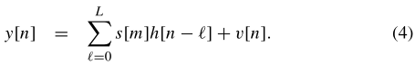

The unknown channel coefficients are  where L is the order of the filter. In this lab we will employ a linear equalizer. The goal of a linear equalizer is to find a filter that removes the effects of the channel. Let  be an FIR equalizer. The equalizer will be applied to the received signal so that

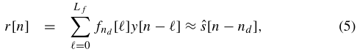

Where nd is the equalizer delay and is generally a design parameter. Generally allowing nd > 0 improves performance. The best equalizers consider several values of nd and choose the best one.

**1.1 Linear Least Squares**

The main mathematical technique that will be used in this lab is known as linear least squares, which will be used both for estimating the channel and for computing the equalizer. Let A denote a N × M matrix. The number of rows is given by N and the number of columns by M. If N = M we say that the matrix is square. If N > M we call the matrix tall and if M > N we say that the matrix is fat. We use the notation AT to denote the transpose of a matrix, A∗ to denote the Hermitian or conjugate transpose, and Ac to denote the conjugate of the entries of A. Let b be a N × 1 dimension vector. The 2-norm of the vector is given by .

Consider a collection of vectors  . We say that the vectors are linearly independent if there does not exist a set of nonzero weights {αn } such that  . In  , at most N vectors can be linearly independent. We say that a square matrix A is invertible if the columns of A (or equivalently the rows) are linearly independent. If A is invertible, then a matrix inverse A−1 exists and satisfies the properties . If A is tall, we say that A is full rank if the columns of A are linearly independent. Similarly, if A is a fat matrix, we say that it is full rank if the rows are linearly independent.

Consider a system of linear equations written in matrix form



where A is the known matrix of coefficients sometimes called the data, x is a vector of unknowns, and b is a known vector often called the observation vector. We suppose that A is full rank. First consider the case where N = M. Then the solution to Eq. (6) is . Now suppose that N > M. In this case A is tall and the system overdetermined in general. This means there are N equations but M unknowns, thus it is unlikely (except in special cases) that an exact solution exists. In this case we pursue an approximate solution known as least squares. Instead of solving Eq. (6) directly we instead propose to find the solution to the squared error



Using matrix calculus, it can be shown that the solution to this problem assuming that A is full-rank is



Note that A ∗ A is a square matrix and invertible because of the full-rank assumption. We refer to x LS as the linear least square error (LLSE) solution to Eq. (6). We use the squared error achieved by xLS to measure the quality of the solution. With some calculus and simplifying, it can be shown that the least squares error achieved is given by

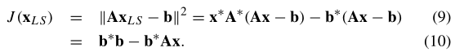

Now you will use the least-squares solution for channel estimation and equalization.

**1.2 Channel Estimation**

There are several different criteria for designing an estimator including the maximum likelihood criterion, minimum mean squared error, and least squares. Of these, perhaps the least squares technique is the simplest thus we will discuss it here. The added advantage of the least squares estimator is that in AWGN the least squares estimator is also the maximum likelihood estimator.

Suppose that  is a known training sequence. This is a set of symbols that is known a priori. Suppose that the known training symbols are inserted into the transmitted sequence such that s[n] = t[n] for n =0,1,...,Nt . To solve for the estimate of the channel using the LLSE solution in Eq. (8), it is necessary to form a system of linear equations. Consider

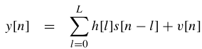,

where s[n] = t[n] for n = 0,1,...,Nt . Since s[n] is unknown for n ≥ Nt (that is the unknown data), we need to write the squared error only in terms of the unknown data. With this in mind the least squares problem is to find the channel coefficients that minimize the squared error

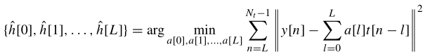.

The summation starts with n = L to ensure unknown data is not included. The least squares estimator is simply a generalization of the narrow band estimator. A “straightforward” way to solve this problem is to differentiate with respect to a ∗ [m], build a set of linear equations, and solve. An alternative approach is to build a suitable set of linear equations. This is a powerful approach to solve a large class of least squares problems. First write the observed data as a function of unknown in matrix form

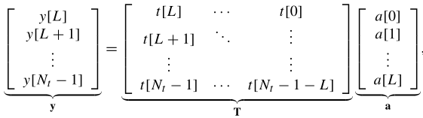,

where we refer to T as the training matrix. If T is square or tall and full rank, then T∗T is an invertible square matrix, where ∗ stands for conjugate transpose (Hermitian). The tall assumption (square with equality) requires that

Nt − L ≥ L + 1,

or, equivalently

Nt ≥ 2L + 1.

Generally choosing Nt much larger than L+1(the length of the channel) gives better performance. The full rank condition can be guaranteed by ensuring that the training sequence is persistently exciting. Basically this means that it looks random enough. Randomt raining sequences perform well while the all constant training sequence fails. Training sequences with good correlation properties generally satisfy this requirement.

**1.3 Channel Equalizer Calculation**

With an estimate of the channel  in hand, the next task is to remove the effects of this channel. In this lab we consider linear equalization that performs the operation in Eq.(5). There are several approaches for designing a linear equalizer. In this lab we compute the least-squares equalizer. The objective is to find a filter such that

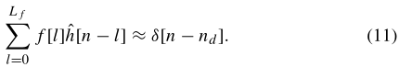

Except in trivial channels Eq. (11) can not be satisfied exactly. The reason is that an FIR filter requires an IIR filter. The parameter nd in Eq. (11) is the equalizer delay and is generally a design parameter. Generally allowing nd > 0 improves performance. The best equalizers consider several values of nd and choose the best one.

A straightforward approach is the least-squares equalizer. The key idea is to write a set of linear equations and solve for the filter coefficients that ensure that the Eq. (11) minimizes the squared error. Writing Eq. (11) in matrix form

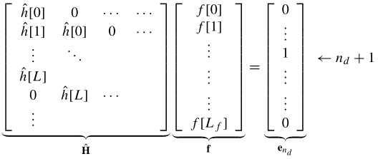

The matrix  is a type of Toeplitzmatrix, sometimes called a filtering matrix.

Assuming that  is full rank, which is guaranteed if any of the channel coefficients are nonzero, the linear least squares solution is



The squared error is measured as . The squared error can be minimized further by choosing nd such that  is minimized. This is known as optimizing the equalizer delay. The equalizer order is L f . The choice of Lf is a design decision that depends on L. The parameter L is the extent of the multipath in the channel and is determined by the bandwidth of the signal as well as the maximum delay spread derived from propagation channel measurements. The equalizer is an FIR inverse of an FIR filter. As a consequence the results will improve if Lf is large. The complexity required per symbol, however, also grows with Lf .Thus there is a tradeoff between choosing large Lf to have better equalizer performance and smaller Lf to have more efficient receiver implementation.

**1.4 Direct Least-Squares Equalizer**

Using the channel estimation and equalization methods from the previous sections requires solving two least squares estimation problems. This can be computationally expensive. Designing the equalizer estimate directly from the received sequence can be more efficient as this method only requires formulating a single least-squares estimation problem. The least-squares equalizer requires solving two least-squares problems. The first is to estimate the channel coefficients using a least squares approach; the second is to estimate the least-squares equalizer. An alternative approach is a direct solution. This means that the equalizer is found directly from the observed training data. Such an approach is somewhat more robust to noise. Consider the received signal after linear equalization with delay nd

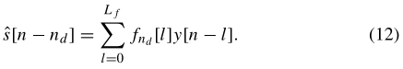

Suppose that s[n] = t[n] for n = 0,1,...,Nt is the known training data. Then  for n = nd ,nd + 1,...,nd + Nt . Rewriting Eq. (12) with knowledge of the training data

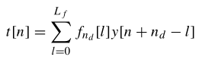

for n = 0,1,...,Nt .

Now build a linear equation

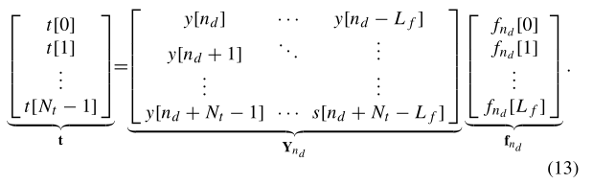

Solving under the assumption that Y is full rank, which is reasonable in the presence of noise, the least squares solution is



The squared error is measured as  . The squared error can again be minimized further by choosing n d such that  is minimized.

Note that to ensure that Y is square or tall requires Lf ≤ Nt − 1. Thus the length of the training determines the length of the equalizer. This is a major difference between the direct and indirect methods. With the indirect method, an equalizer of any order Lf can be designed. The direct method, on the other hand, avoids the error propagation where the estimated channel is used to compute the estimated equalizer. Note that with a small amount of training the indirect method may perform better since a larger L f can be chosen while a direct method may be more efficient when Nt is larger.

Questions

Answer the following questions.

1. In your implementation of toeplitz.vi you were required to build a Toeplitz matrix given the initial row and column of the matrix. Notice the first element of row and column should be equal. What will your VI do if the initial element of each array is different?

2. Test your channel equalizer algorithm using the channel h[0] = 1, h[1] = 0.35e jπ/4 . You can modify the length of the equalizer from the front panel of the simulator. In the absence of noise, what happens to the received signal constellation when you set the equalizer length to one? Describe what happens to the constellation as you vary the equalizer length from one to six.

3. Using the same channel, observe how the bit-error rate performance of your equalizer varies with SNR for various equalizer lengths. Plot average BER as a function of SNR for Lf + 1 = 1 and Lf + 1 = 6. Vary SNR from 0 dB to 14 dB in increments of 2 dB. Use the default value for any parameter not specified below.

• Modulation type = QPSK

• Packet length (bits) = 500

• Equalization method = Direct

• Equalizer length (Lf + 1) = 1,6

• ISI Channel = {h[0] = 1, h[1] = 0.35e jπ/4 }

Remember if signal power is held constant, then decreasing noise power, N0 , is equivalent to increasing SNR. To observe errors at high SNR you will need to run significantly more iterations in the simulator.

Use a logarithmic scale for BER and a dB scale for SNR in your plot. Also, on the same graph, plot BER as a function of SNR for Lf +1 = 1 in an AWGN channel for the same range of SNR values. For this curve, you will only need to plot error rates in excess of 10−6

**3 Lab Experiment**

**3.1 Narrowband Channel**

In this part of the lab experiment you will observe how the channel of a real wireless link impacts the received QAM constellation. To begin, setup the following parameters in your system using the appropriate controls in top rx.vi and top tx.vi:

• Packet length = 500 bits

• TX sample rate = 20 MSamp/sec

• TX oversample factor = 200

• RX sample rate = 2 MSamp/sec

• RX oversample factor = 20

• Equalizer length = 1

• Capture time = 3.5 msec

Use the default values for any parameters not listed above. Next, in order to observe the impact of the wireless channel on your received QAM constellation you will need to rewire part of the block diagram in receiver.vi. As shown in Figure 4, rewire the wire labeled “recovered symbols” so it is connected to the output of synchronize.vi and not strip control.vi. This will allow you to observe the received constellation prior to equalization. Notice that since this modification bypasses strip control.vi it will plot the entire received sequence (i.e., including training data and any additional symbols or zeros at the end of the array).

Questions

After setting up the appropriate parameters and modifying receiver.vi as previously described, run your system and observe how the narrowband channel alters your received constellation.

1. What is the symbol rate of your system?

2. What is the passband bandwidth of your system?

3. Based on your observations, describe the impairments imparted to the received constellation. You may need to “auto-scale” the axes of your constellation in receiver.vi in order to observe the effects of the narrowband wireless channel.

**3.2 Wideband Channel**

In this part of the lab experiment you will learn about the power-delay profile of the channel. The power-delay profile of a continuous-time channel h(τ) is P(τ) = E ? |h(τ)| 2 ? , (15)

where E{·} is the expectation operator. The discrete-time equivalent of the power-delay profile can be computed from the estimated channel ˆ h[n] (i.e., P[n] = E{| ˆ h[n]| 2 }). In this part of the lab experiment you will study the power-delay profile of a wideband system.

Set up the following parameters in your system:

• Packet length = 500 bits

• TX sample rate = 20 MSamp/sec

• TX oversample factor = 4

• RX sample rate = 10 MSamp/sec

• RX oversample factor = 2

• Channel estimate length = 6

• Equalizer length = 6

• Capture time = 80 μsec

Use the default values for any parameters not listed above. You will now start the transmitter of your system (i.e., top tx.vi). Place your antennas at an elevated height so they will be free of obstructions and able to capture a large portion of the multipath energy in your wireless environment. Begin receiving packets using top rx.vi. Record the estimated channel ˆ h[n] for at least 5 of the transmitted packets. Discard any measurements in which the bit-error rate of the received packet exceeds 0.10; typically BER exceeds 10 −1 when errors in frame detection occur. You should also disable frequency offset correction from the front panel of top rx.vi, as this can lead to additional unwanted errors. Also, be sure to rewire the wire labeled “recovered symbols” so it is connected to the output of strip control.vi and not synchronize.vi (in contrast to the previous section).

Questions

Answer the following questions about this part of the lab experiment.

1. What is the symbol rate of your system?

2. What is the passband bandwidth of your system?

3. Based on the data you have collected in this part of the experiment, make a plot of the power-delay profile of the wideband wireless link in lab. Discard any outlying observations that might have been caused by errors in frame detection or noise. Average the power-delay profile over the remaining observations.